Appraisal

HRMS

V001.1

 | Name | Role | Signature | Date
Author | Ramu Nunna |  |  | 17/09/2015
Reviewer
Approver

Table of Contents
1. Introduction 3
1.1. Purposes 3
1.2. Scope 3
1.3. Audience 3
1.4. Reference 3
2. Functional Overview 3
2.1. Major Functions 3
2.2. Functions Out of Scope 4
2.3. Assumptions / Constraints / Dependencies (A /C /D) 4
3. Functions 5
3.1. Common function 5
3.2. Event Log Screen 6
3.3. Set Date 9
3.4. Key Result Objectives 12
3.5. Objective Set Review 15
3.6. Objectives Vs Results 18
3.7. 19

Introduction

Purposes

The purpose of this document is to define the Appraisal module functionality, which should be integrated with SmartHR. This document aims to capture all the details that are essential for the appraisals of the employees by their superiors.

Scope

The scope covers the entire Appraisal functionality as given below

- Setting the header, heading & sub heading details depends up on employee type and designation.
- Creating the appraisal cycle .
- Submitting the rating form to the HR for approval.
- Capturing the feedback details from students.
- Creating the subject .
- Submitting subject details from staff and that details will go to HOD approval.
- Review appraisal details by HR.
- Freeze appraisal Cycle.
- Crate satisfaction heading & sub heading masters
- Submitting employee satisfaction from by employee.
- Finally generate report for HR depending up on feed back of employee.

Reference

Appraisal Module URS document

Functional Overview

Major Functions
This module is developed to capture the workflow, processes and transactions of the current Appraisal .In system one appraisal cycle has to be active.
Firstly we need to create Heading ,header & sub heading masters depending upon employee type and designation. After create ting this we need to create appraisal cycle and satisfaction heading & subheading details also. Depending upon above masters appraisal form & employee satisfaction will generate dynamically.
Case 1
We need to capture subject details(semester wise) for each employee .it has approval process. Firstly employee submit form to HOD.HOD has to review & approve that form.
Employee HOD
Case 2
We need to capture feedback from students for each staff. It has to round for 5 out of feedback. For this we are providing upload option ,they need to upload semester wise feed back for each staff.

Case 3
After creating appraisal cycle we need select eligible employee list .after that we need iniatite appraisal form to HOD.HOD has to give ratings under his employees (semester wise(even & odd)).If submit the form to HR. When HR review the appraisal for she has to considering these details.

1. Subject details
2. Feedback from students
3. HOD Ratings
4. How many Papers that employee Published.

Depending upon above information HR will enter revised salary details. After that she will generate report for old & revised salary details. After finishing all initiated employees HR has to freeze appraisal cycle.HR has to create new appraisal cycle then above process will repeat.
Appraisal Cycle Eligible Employees Initiate Rating Appraisal Form(Filled by HOD Under employees) HR(Review the Appraisal Form, add salary increment details) Freeze

Case 4
Employee Satisfaction form
Each employee has to submit employee satisfaction form for semester wise. In that we are capturing how employee satisfied with organization. We are hiding these details but we are generating final report for HR how employees satisfied organization with head count.

Functions Out of Scope

N A

Assumptions / Constraints / Dependencies (A /C /D)

Description of Assumptions / Constraints / Dependencies
Assumptions | - Appraisal cycle will active one.  - Student feed back will capture semester wise  - HOD feedback will capture semester wise.
Constraints | N A
Dependencies | - Employee related features EDB module

Functions

Common function

Sr. No. | Function Name | Purpose
 | Employee listing | Employee selection window to select employees. This by default has a search option too.
 | Validations | We need to use common alert function.

Code

We are using bootstrap technique for front end designing. For connection SQL server to VS studio we are using ADO.net .

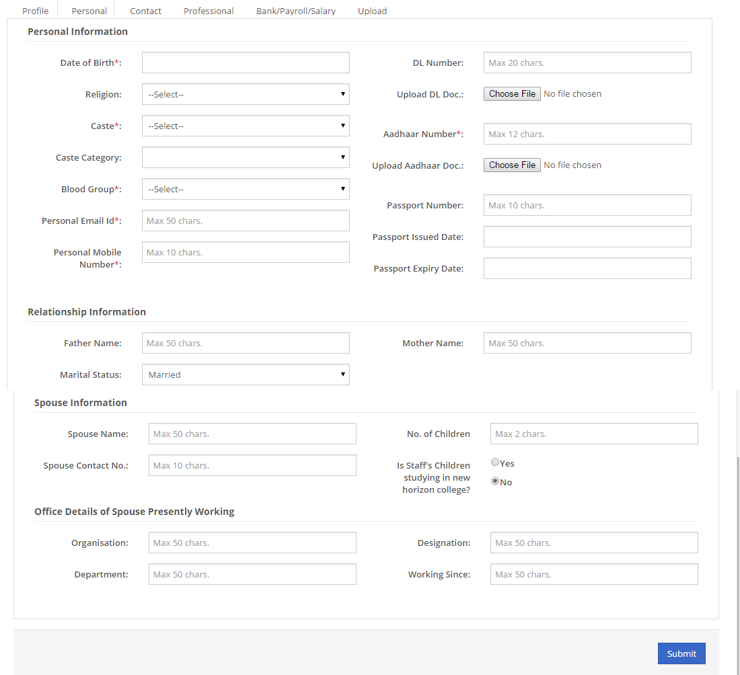

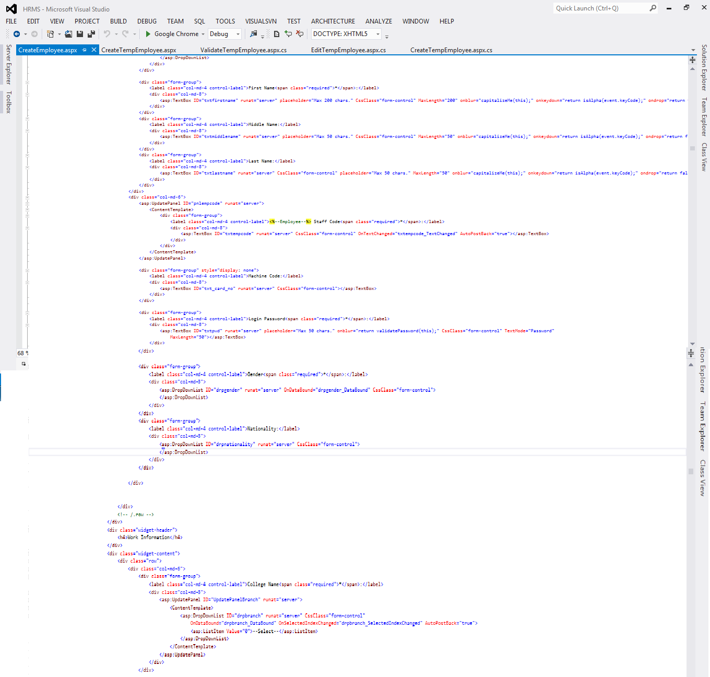

1. Open connection
2. Send parametes using sqlparmeter[].
3. Send command type (Text,Storedprocedure)
3.Close connection

For Insert we are using ExexuteNonQuery.
For showing data we are using ExecuteDataSet.
For getting insert column ID we are using execute scalar.

By using dataset we are manipulate data then we are display in grid view. For data manipulation in servere we are using sqltransaction, why because any error occure between transaction it will roll back that process.

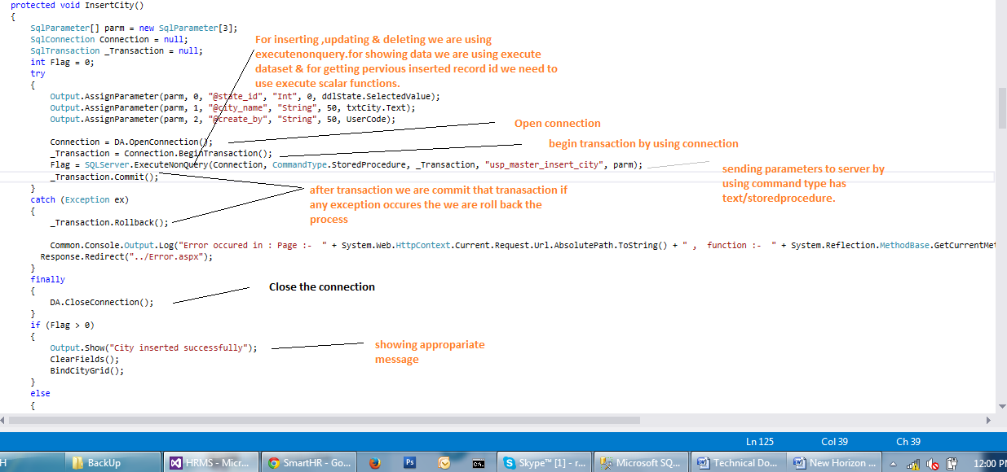

Error Handling :

By using try ,catch & finally we are handling error. By using common log function we capturing error.
We are creating error folder in current source code path with date wise it will show. In that we are showing which page,which function error is occurring and what is error and which time it is occur. By using this we can find error easily.
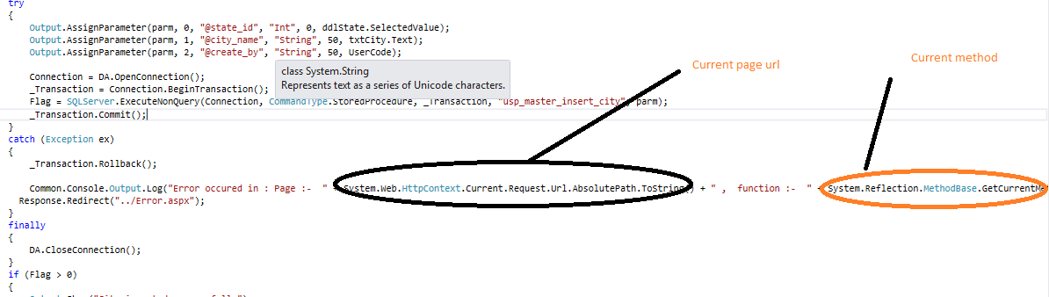

Database Architecture

Database Fields along with table structure.

Attributes

Tables

tbl_appraisal_eligible_employee
tbl_appraisal_employee_hierarchy
tbl_appraisal_employee_rating
tbl_appraisal_employee_rating_details
tbl_appraisal_employee_satisfaction
tbl_appraisal_employee_subject
tbl_appraisal_employee_subject_details
tbl_appraisal_feedback
tbl_appraisal_master_cycle
tbl_appraisal_master_feedback
tbl_appraisal_master_header
tbl_appraisal_master_heading
tbl_appraisal_master_rating
tbl_appraisal_master_sat_header
tbl_appraisal_master_sat_sub_header
tbl_appraisal_master_sub_heading
tbl_appraisal_master_subject

tbl_appraisal_master_cycle

Sr No | Entity | Description | Type | Length
 | app_cycle_id | slno for identifying the attendance log uniqly | Int | -
 | company_id | Identifying which company | Int | -
 | from_year | Capturing appraisal from year. | Varchar | 4
 | from_month | Capturing appraisal from month. | Varchar | 3
 | to_year | Capturing appraisal to year. |  | 4
 | to_month | Capturing appraisal to month |  | 3
 | freeze | For checking appraisal cycle is freezed /not freezed | Bit | 1
 | create_by | Who created this record | Varchar | 50
 | create_date | Capturing punch date and time | Datetime | -
 | update_by | Who updated this record | Varchar | 50
 | update_date | Capturing punch date and time | Datetime | -
 | status | For checking appraisal cycle active /in active | Bit | 1

Database Design
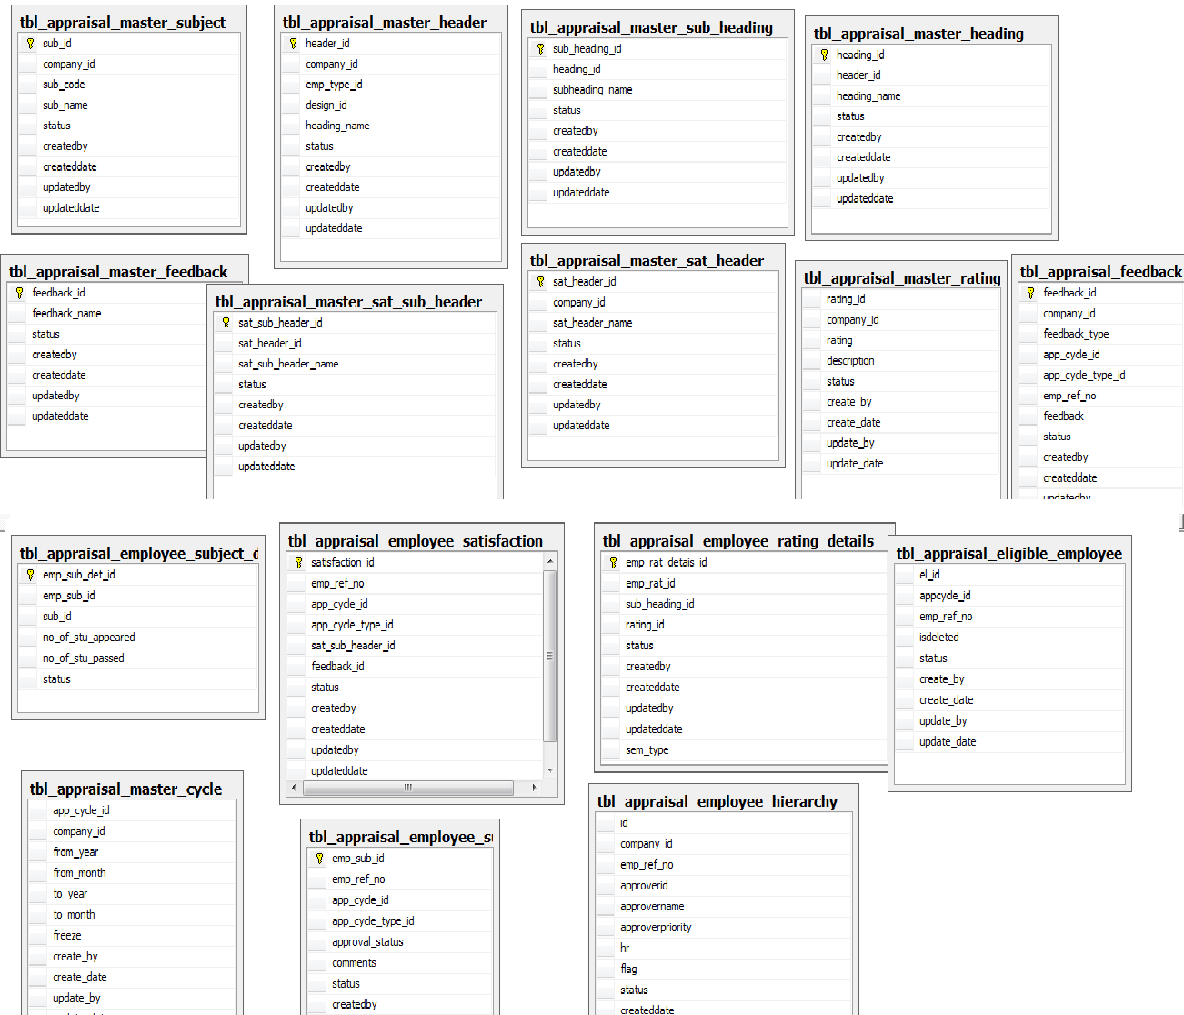
Server Function Design
- Register
Client to Server : user name, password Server to Client : Success / Fail, Error message
Action on Server : create employee
- Login
Client to Server : user name, password
Server to Client : Success / Fail, Session id / Error message
Action on Server : verify user name & password
set session id of user
- Logout
Client to Server : user name, Session Id
Server to Client : Success / Fail, Error message
Action on Server : clear session id & session expire time

